**Docker Installation Steps for Ubuntu**

1. sudo apt-get install
2. Install packages to allow apt to use a repository over HTTPS:

$ **sudo apt-get install apt-transport-https ca-certificates curl software-properties-common**

1. Add Docker’s official GPG key:

$ **curl -fsSL https://download.docker.com/linux/ubuntu/gpg | sudo apt-key add –**

1. Verify that the key fingerprint is:

9DC8 5822 9FC7 DD38 854A E2D8 8D81 803C 0EBF CD88

**sudo apt-key fingerprint 0EBFCD88**

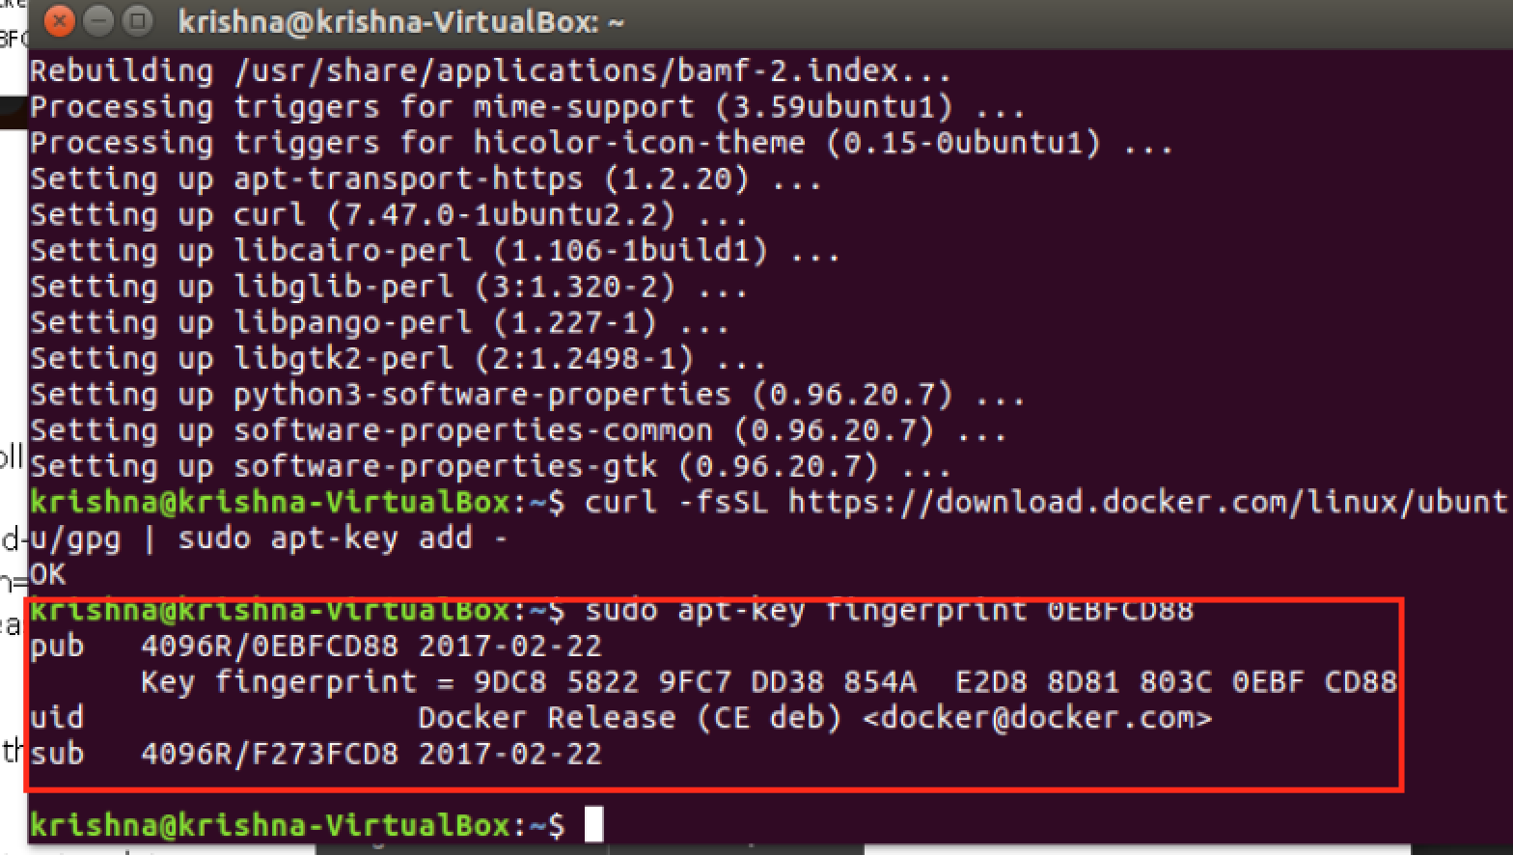

1. Use the following command to set up the **stable** repository:

**$ sudo add-apt-repository “deb [arch=amd64]** [**https://download.docker.com/linux/ubuntu \**](https://download.docker.com/linux/ubuntu%20/)

**$(lsb_release -cs) Stable”**

6. Update the apt package index and install latest version of Docker CE

**$ sudo apt-get update**

**$ sudo apt-get install docker-ce**

7. Running Hello World

